Music Therapy Report – Richard Trethewey

I must start by expressing enormous gratitude and heartfelt thanks for your award of a £1000 grant towards my postgraduate Music Therapy course. It came at a difficult time and made the seemingly impossible, possible.
I am incredibly lucky to live in Cornwall, surely one of the UK’s most beautiful regions but unfortunately, we are not well served by training courses for Music Therapy! Music Therapy MA’s are delivered on a part time basis, meaning I was on campus one day a week plus placements. Because of this it was not feasible to relocate to South Wales and leave good employment and friends and family so I decided to commute from Cornwall to Wales one day a week. Three years of 4.20am alarm bells, a 368 mile round trip and then the actual training certainly tested my resilience...and bank account! The award came during my final year which really enabled me to see the finish line in sight when I was uncertain of how I would finance everything in the months ahead.
I was extremely fortunate to be able to do my placements down in Cornwall and it was during this time that everything started to fall into place in terms of theoretical and clinical practice and how they fit together in real life settings. My first placement saw me shadowing an experienced therapist working in a variety of settings, from private clients, a Downs Syndrome support group, special school work and hospital work. My second year placement saw me working in a dementia care home in Cornwall with a Therapist who had also trained on the South Wales course. I gained a wealth of experience and confidence during this time. It was a daunting prospect having your very first client and I know we all felt the weight of responsibility for what we were doing. I was extremely lucky to work with a wonderful woman who was living with Alzheimer’s disease. Working together with this lady we naturally covered all the different techniques I had been studying and it felt like we were genuinely helping each other. We played improvised music, danced, laughed, talked and formed a strong therapeutic relationship. This work led to some of my footage of sessions being used in a fundraising campaign by the charity providing care which sadly came about after this lady had passed away but meant I then built a strong relationship with her family too. My final year placement was at a Child Development Centre in Cornwall where I worked with children aged 3-4 with various conditions but particularly Autism.
During my final year I wrote my dissertation on the subject of Music Therapy and dementia, particularly investigating whether Music Therapists thought that using music from the place a client feels they are from could improve a sense of self and strengthen a sense of identity. I used a creative methodology, playing music from where my participants felt they were from and then interviewed them about how this made them feel and about their clinical work and whether they feel it could be applied to those living with dementia. One of the major outcomes of the study was that it highlighted this methodology as having potential for application to many areas. These included training health care professionals in the importance of considering client’s identity to the use of creative methodologies in various interview situations.
Since qualifying in the summer of 2017 I have been fortunate to find and create a variety of work. I currently work one day a week in the dementia care home I did my second-year placement in, as well as two days a week at a children’s hospice. I work in two mainstream primary schools in Cornwall as well as having two private clients.
As well as being a Music Therapist I am a performing musician and have been involved in many exciting projects recently. Last December I performed with Cousin Jack’s Theatre, performing a production of the acclaimed ‘Mousehole Cat’ which will run again this winter. In early 2018 a band I play with ‘The Rowan Tree’ won ‘Kan rag Kernow’ (Song for Cornwall) which meant we then represented Cornwall against all the other Celtic nations at the Pan Celtic in Ireland, where we placed second after a joint first place with Ireland! In May we represented Cornwall again in the Netherlands at the Liet Minority Language Song Competition, for any minority language from across Europe. There were fourteen bands competing from right across Europe and much to our surprise we won! Over the summer I have been involved in running children’s workshops based on the ancient Cornish tradition of Shalall. This is the tradition of a processional band playing improvised instruments through their village with the aim of causing havoc! In our workshop we learned an ancient Cornish song, made instruments from scrap and then processed around their village!
In the coming year I am very much looking forward to continuing my clinical work and developing my practice as I gain more experience. Thankyou again for your very generous grant which enabled me to finish my final year more easily and has therefore made this all possible.
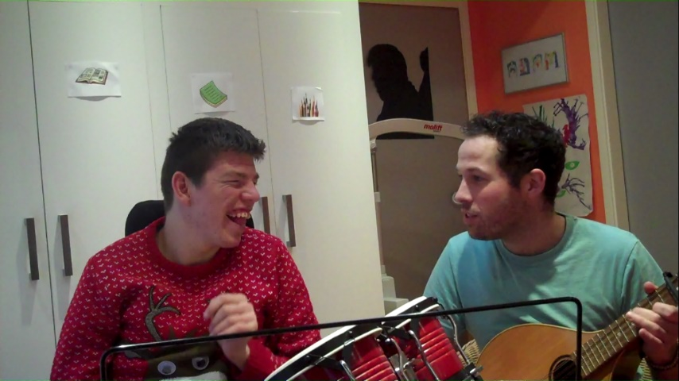

Richard Trethewey

